Deep Learning

Lab 1

Name: Yadukrishnan

Reg No: 21BAI1210

Slot: L55 + L56

[Github link](https://github.com/yadu-tv/deep-learning-lab) to all the below codes

Software used:

Tensorflow, Python

* MNIST Dataset

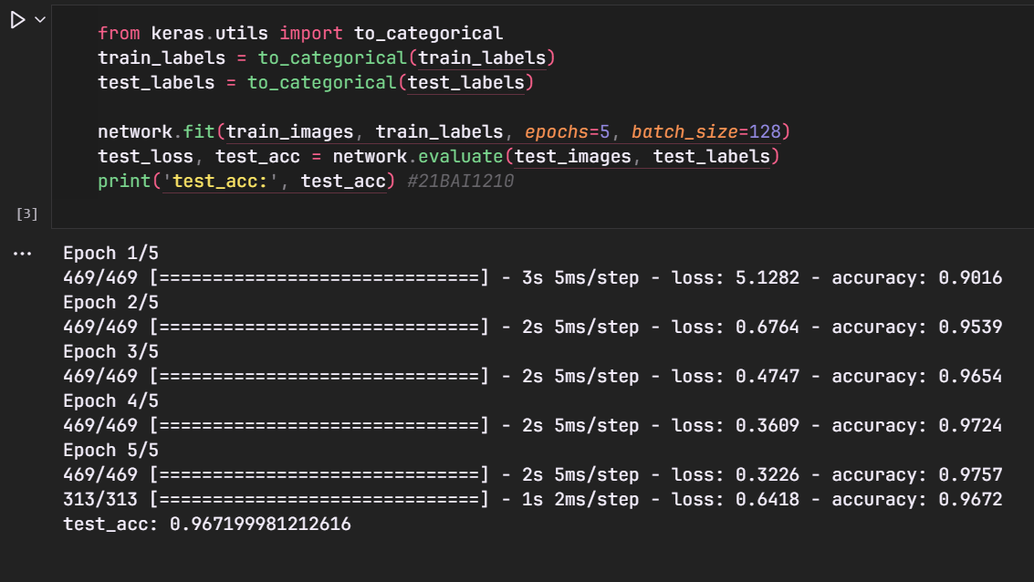

* Fashion MNIST Dataset

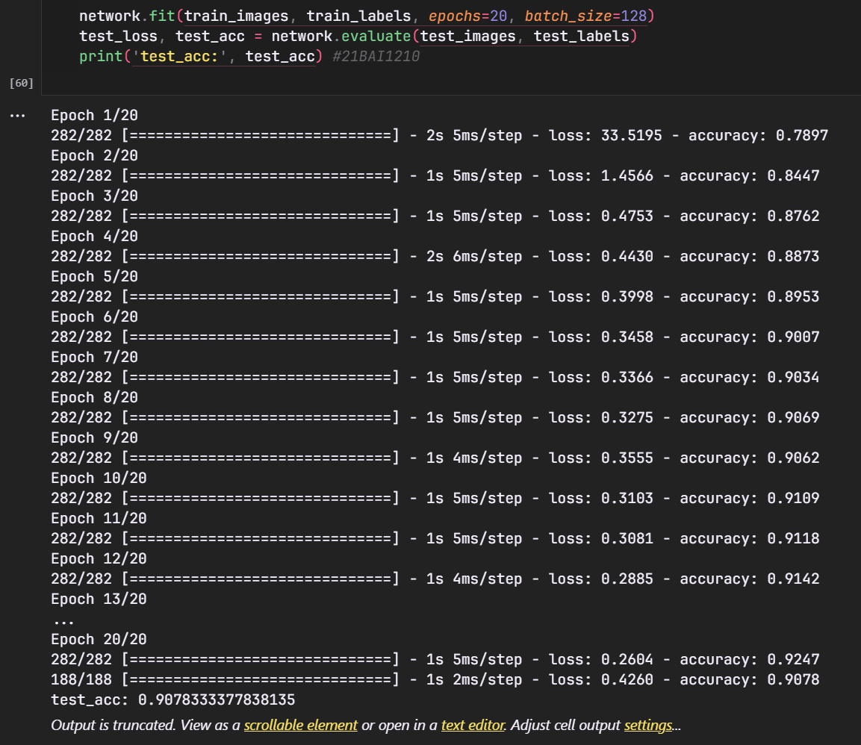

* Cats vs Dogs Dataset

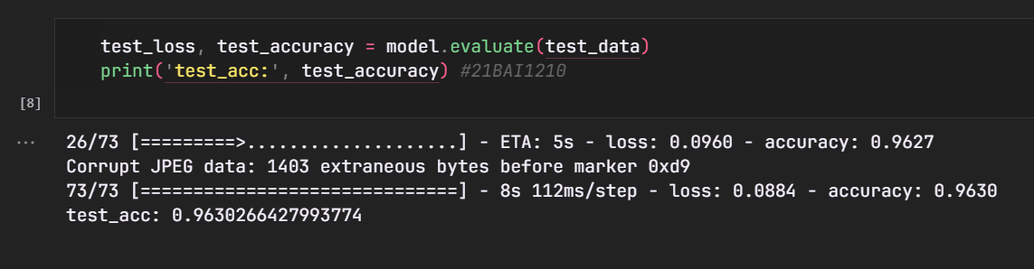

* Patch Camelyon Dataset

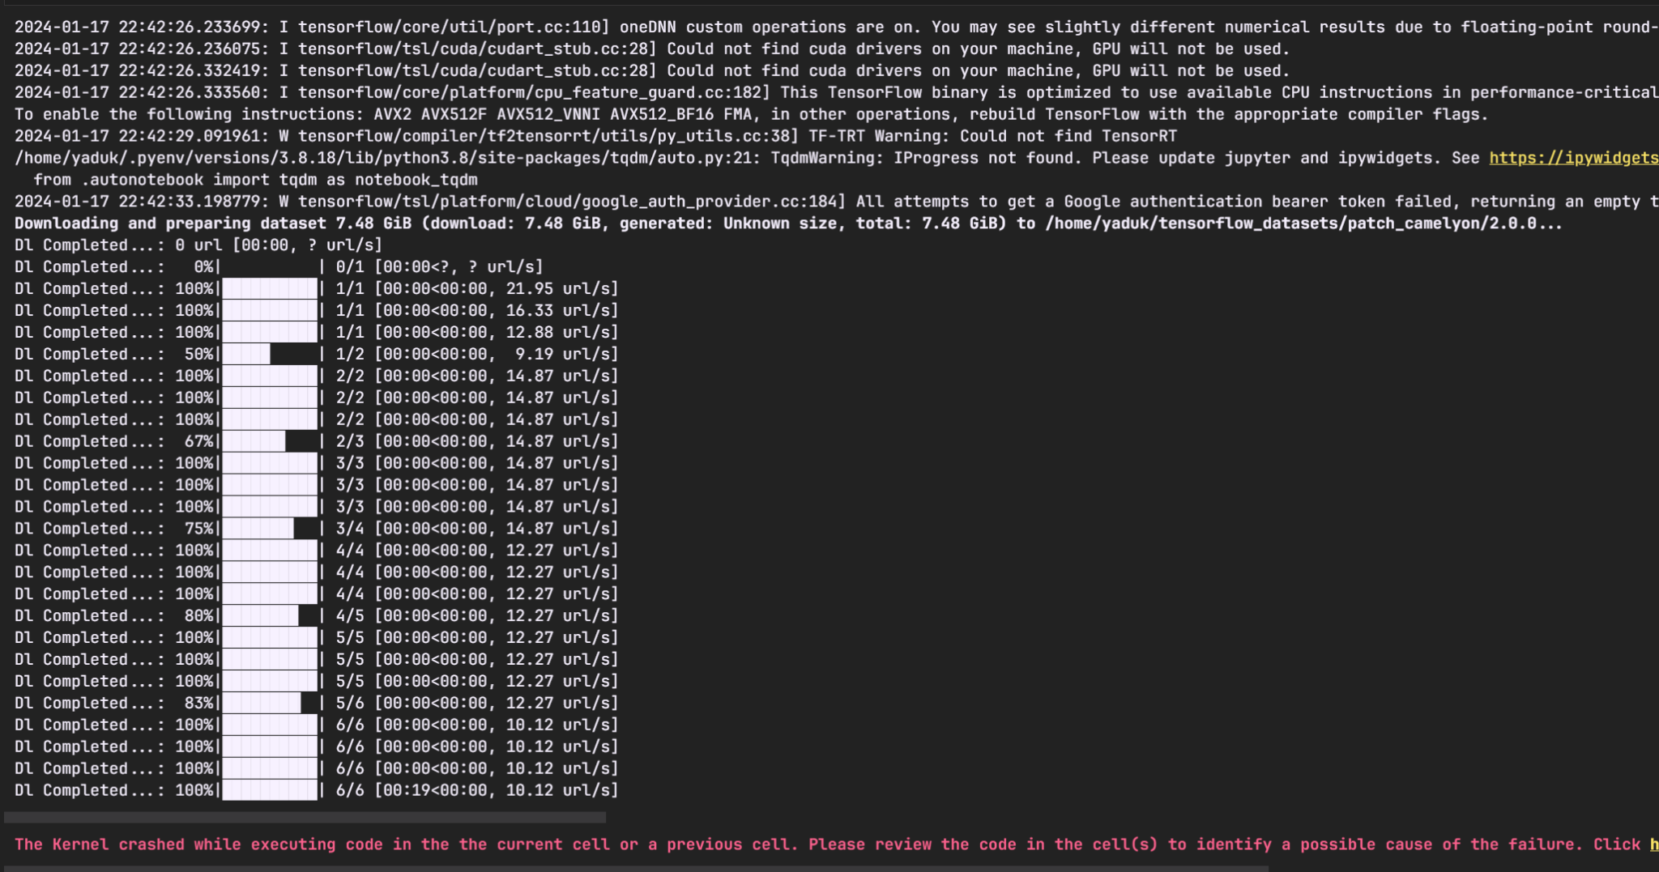

Data could not be loaded due to memory leaks. The data is stored in a single array with 300k images. Requires high end devices or advanced implementations to import the data.